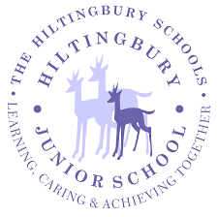
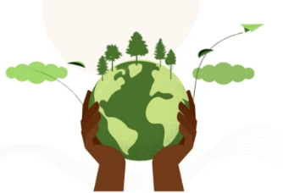
Is there enough for everyone?
Year 4 Autumn 1

CONCEPTS
Sustainability  Ability to meet the needs of the present without compromising the needs of the future | Resourcefulness  The ability to find clever and effective solutions to problems, especially when resources are limited | Inequality  When things are not the same or fair for everyone | Enough  Having a sufficient quantity or amount of something to meet needs, without being too much (excessive) or too little | Help  Make it easier or possible for someone to do something by offering service or resources

HOOK
Hook day: Local business shares their ethos on sustainability and sharing of resources
Foodbank speaker (inequality/kindness) to set up challenge of collecting items for foodbank/harvest festival

OUR LEARNING JOURNEY

1. What is enough?
OUTCOME

Community Cafe - serve banana bread/ soup? (Like our version of Sewa) TBC

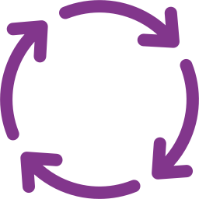

3. What can we do to help?

2. What are people doing to help everyone have enough?
LEAD SUBJECTS

English | Reading | Science | DT | RE | Geography
The Trouble with Dragons- sustainability poetry.  Instructions writing – how to grow your own potatoes.  The Boy who Harnessed the wind – narrative. | The Boy who Harnessed the Wind  Cloud Tea Monkeys  Making inferences using evidence from the text and images | States of Matter – children will learn about solids, liquids and gases, the water cycle and how heating and cooling materials changes them. | Children will practise their chopping, peeling and slicing skills to prepare vegetables to make their own soup. | Sikhism – we will be learning about selfless service performed without expectation of reward or gain through the study of SEWA. | UK Study - focus on distribution of natural resources (food and minerals)

RICH TEXTS

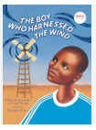
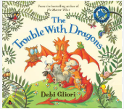
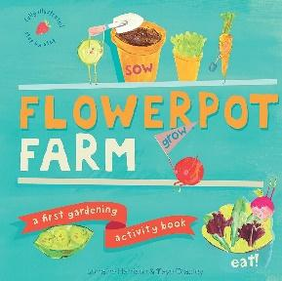
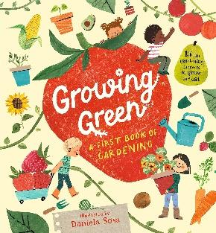
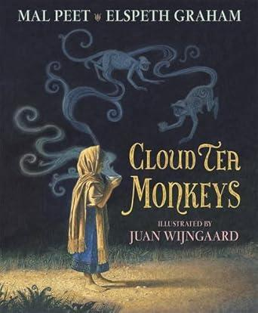

SUBJECTS TAUGHT DISCRETELY FROM THE PROJECT

Maths | Computing | French | Music | PDL
In maths this half term we will continue our addition and subtraction with a focus on subtraction. We will finish the term by extending our learning on length and perimeter including the introduction of kilometres as a unit of length | TBC | French: This half term, we are learning how to talk about our families. | Listen2Me – whole class bowed strings tuition from Hampshire Music Service. | PDL: As part of our “Do we all have a voice” project, the children will be learning how to stand up for themselves and others.

