Year 4 Long Term Reading Overview 2024-2025
Autumn 1 | Autumn 2 | Spring 1 | Spring 2 | Summer 1 | Summer 2
Learning Journey – existing journey | Project: Does everyone have a voice? | Learning Journey – existing journey | Learning Journey -  Existing journey | Learning Journey -  Existing journey | Project: How to succeed against the odds
Multidimensional fluency assessment – 2 weeks  Text: Cloud Tree Monkeys  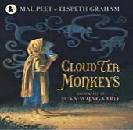  by Peet & Graham |   Text: Malala’s Magic Pencil by Yousafzai | Text: Harklights by Tilley  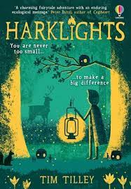 | Text: Beowulf by Jones  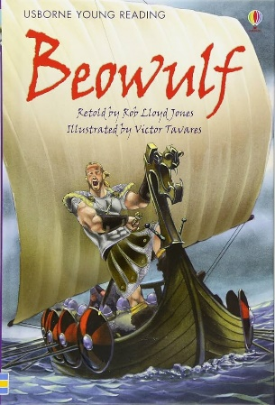 | Text: To be updated, alongside development of new curriculum and children’s needs. | Text: Shackleton’s Journey by William Grill  

