Year 4 Writing Overview 2024/25
Persuade Inform Entertain Discuss
Autumn 1 | Autumn 2 | Spring 1 | Spring 2 | Summer 1 | Summer 2
Learning Journey 1 | Learning Journey 1 | Learning Journey 1 | Learning Journey | Learning Journey 1 | Learning Journey
Text:  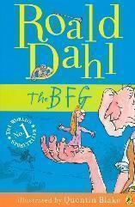  The BFG  Outcome: Police appeal for the giant | Texts:  Rosa Parks  Emmeline Pankhurst  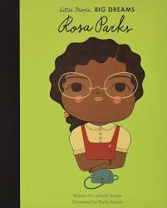  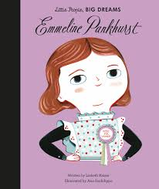  Outcome:  Police report  Speech  First person narrative | 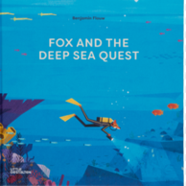  Texts:  Fox and the Deep Sea Quest  Island  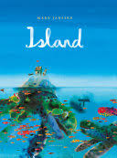  Outcome: Recount of discovering new turtle | 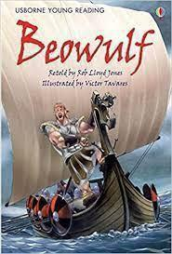  Text:  Beowulf  Outcome: Playscript to be performed in show | Text:  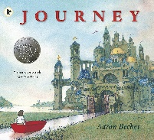  Journey  Outcome:  TBC | Texts:  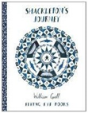  Shackleton’s Journey  Ice Trap!  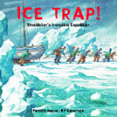  Outcome:  Descriptive narrative
Learning Journey 2  Text: Jack & the beanstalk  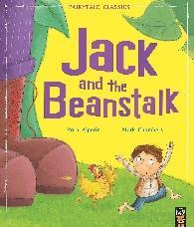  Outcome: Own twist on JATB | Learning Journey 2  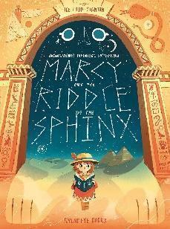  Text: Marcy and the Riddle of the Sphinx  Outcome: Story | Learning Journey 2  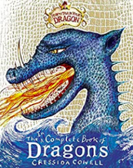  Text: The incomplete book of dragons  Outcome: Information text about own dragon | Beowulf continued | Learning Journey 2  Text:  A Day in the Life of a Poo, a Gnu and You  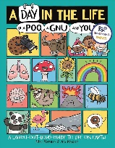  Outcome:  TBC | Shackleton continued

