Year 4 Writing Overview 2025/26
Persuade Inform Entertain Discuss
Autumn 1 | Autumn 2 | Spring 1 | Spring 2 | Summer 1 | Summer 2
Learning Journey 1 | Learning Journey 1 | Learning Journey 1 | Learning Journey | Learning Journey 1 | Learning Journey
Text:  The Trouble with Dragons  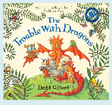  Outcome: Free verse on sustainability | Texts:  Rosa Parks  Emmeline Pankhurst  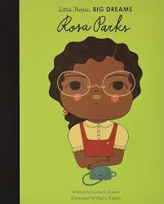  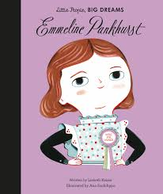  Outcomes: Persuasive speech; first person narrative | Texts:  Fox and the Deep Sea Quest  Island  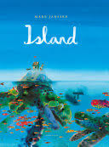  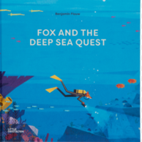  Outcome: Recount of discovering new turtle | Text:  Beowulf  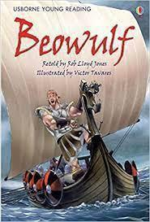  Outcome: Play script to be performed in show | Text:  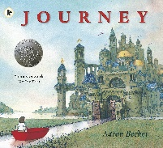  Journey  Outcome: Retelling of an adventure story | Texts:  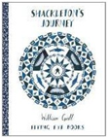  Shackleton’s Journey  Ice Trap!  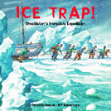  Outcome:  Descriptive narrative
Learning Journey 2  Texts: Flowerpot Farm & Growing Green  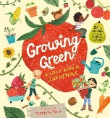  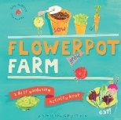  Outcome: Instructions for how to plant a potato | Learning Journey 2  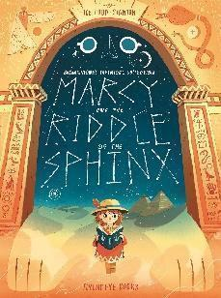  Text: Marcy and the Riddle of the Sphinx  Outcome: Story | Learning Journey 2  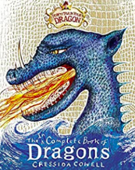  Text: The incomplete book of dragons  Outcome: Information text about own dragon | Beowulf continued | Learning Journey 2  Text: A Day in the Life of a Poo, a Gnu and You  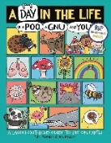  Outcome: Information text in the form of a comic strip | Learning Journey 2  Text:  Emmanuel’s Dream  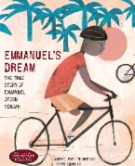  Outcome: Persuasive letter
Learning Journey 3

Text: The Boy who Harnessed the Wind
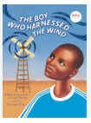

Outcome: Retelling a story

