Young Leaders Wanted

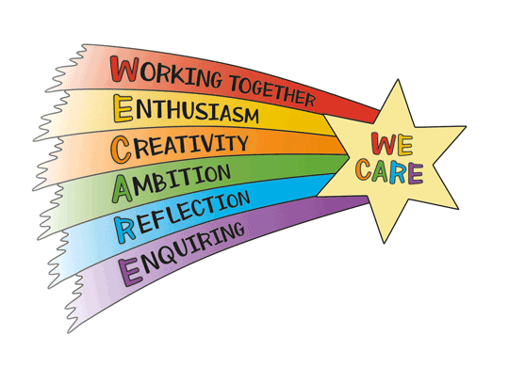
Would you like to represent your class and year group as a Young Leader? Can you demonstrate the following?
- A role model for our school values
- Reliable and Responsible
- Friendly and approachable
- An active listener
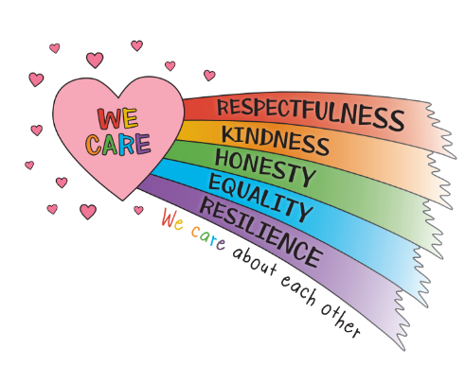
- Able to remember things
- Honesty
- Equality – seeking and valuing everyone’s opinions
- Hardworking
- Full of ideas about school issues and improvement

Key areas of responsibility for 2025-2026:
- Lead on whole school improvement priorities, including our outdoor environment development and Reading Shed
- Support with the school’s work developing and promoting our new curriculum
- Conduct surveys with parents and pupils to gather their views
- Be involved in the Year 3 Welcome Event, sharing all about our school
- Plan and lead whole school events, including Remembrance and our Community day
- Lead assemblies to support the above
- And bring your own passion and ideas about priorities you have for school improvement!

Overall, Young Leaders will need to be passionate about leading initiatives to make our school the best possible place to learn.

If you are interested in being a Young Leader, please write a short speech to present to your year group. You may wish to use these headings….
- Why do you want to be a Young Leader?
- What skills/talents do you have that would help you in this role?
- What aspects of the role would you find challenging?
- What aspects of the role would you find rewarding?

We look forward to hearing from you!
We will have one Young Leader per class.

Successful Young Leaders will be announced in assembly on Friday 26th September

