Wellbeing Ambassadors

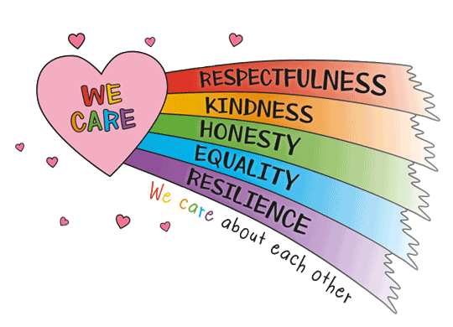
Would you like to represent your class and year group as a Wellbeing Ambassador? Can you demonstrate the following?

- Empathetic
- Offer support to your peers
- Kind and caring
- Responsibility
- Friendly and approachable
- Good at listening to everyone
- Able to remember things
- Reliability

Key areas of responsibility for 2025-2026:
- Promote positive mental health and wellbeing amongst your class and year group
- Help lead World Mental Health Day and Children’s Mental Health Week
- Share key messages on positive mental health in class assemblies
- Be responsible for the Wellbeing Hub
- Be supportive of children in your class/year group who may need comfort and support
- Be supportive of children in your class/year group who may need help with friendships and demonstrating our community values.

If you are interested in becoming a Wellbeing Ambassador, please write a short speech to present to your year group. You may wish to use these headings….
- Why do you want to be a Wellbeing Ambassador?
- What skills/talents do you have that would help you in this role?
- What aspects of the role would you find challenging?
- What aspects of the role would you find rewarding?

We look forward to hearing from you!
Closing date for applications is Monday 22nd September.
Successful School Council reps will be announced in assembly on Friday 26th September.

