

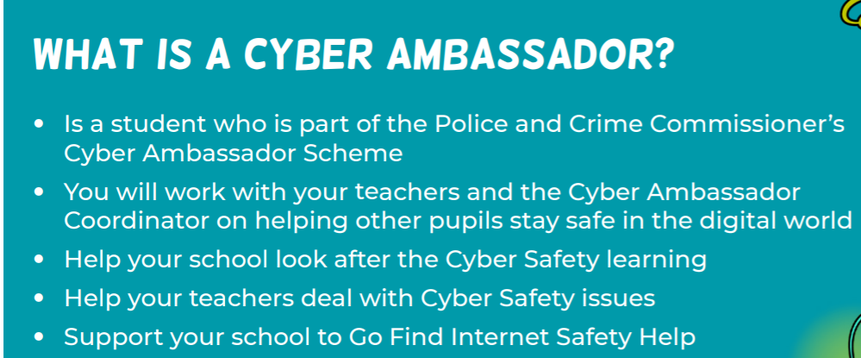


To apply:
Explain to Mrs Deacon why you think you’d be a great Cyber Ambassador! Tell her how you would help people stay safe online and share any ideas you might have to promote internet safety in school. You can choose how to apply.
You can either:
Write a paragraph OR
Make a poster (this can be hand-drawn or done using ICT)
Closing date for applications is Wednesday 24th September and successful applicants will be announced in assembly on Friday 26th September..

