My Social Story about Year 5’s trip to the PGL Residential Centre 2026

On Sunday 22nd March in the afternoon, I will arrive at Hiltingbury Junior School at 3pm with my luggage ready to go on our trip!

When we are all ready, I will get on the coach with all my classmates and we will travel to the PGL Liddington Centre. The journey is around 1hr long. When we arrive, I will be told who I am sharing my room with and will be given time to unpack and chat with my friends. We will then also have a tour of the centre. All the teachers and TAs will be there to help me if I have any questions or I am unsure of anything.

In the evening, we will have a lovely dinner with all of our friends and teachers. We will all have an activity together in the evening outside which will be lots of fun. After this, it will be time to be thinking of getting to bed, ready for a busy day of activities on Monday. The teachers and TAs will be there to make sure that I stay safe. If I have any questions or worries, I can ask all the familiar adults for help.



On Monday morning, after a lovely breakfast with all of my friends, I will join a group with children from across year 5. There will be children from my own class in my group too. I will take part in two activities in the morning, then eat lunch. In the afternoon, I will take part in two more activities. I will ensure to listen to the instructor and follow their advice. The teachers and TAs will be there to help me with this.

Here are some pictures of the activities that we could be enjoying: Canoeing and Abseiling. There are lots of wonderful activities we will be taking part in!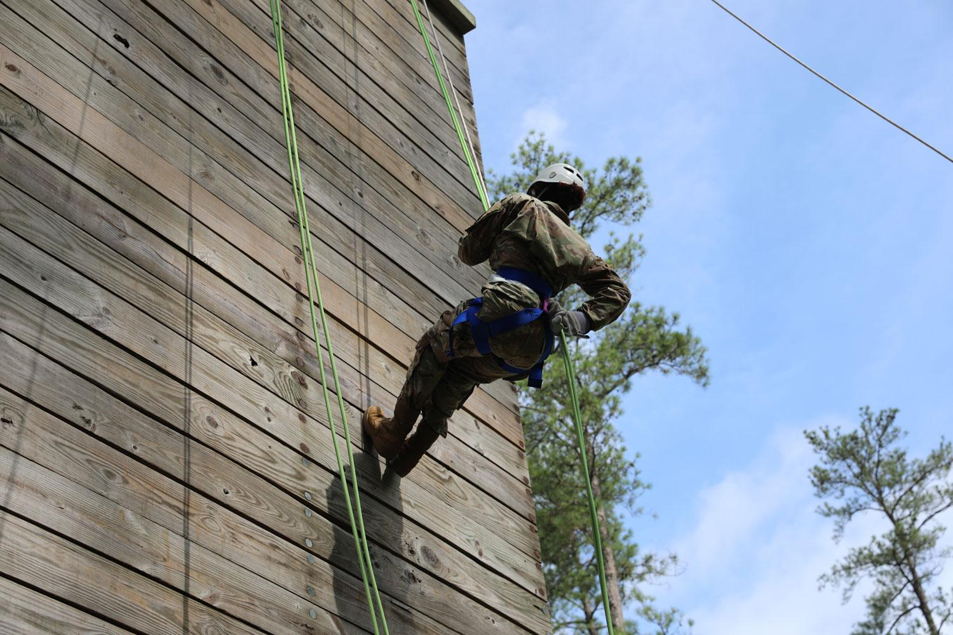

It is important that I listen to instructions and keep myself safe.

After the day’s activities, I will go back to the centre for a lovely dinner. During the evening, before bedtime, we will all be enjoying an evening activity like the day before.

On Tuesday morning, I will eat a lovely breakfast in the canteen with my friends and then I will take part in the next day’s activities. There will be two activities in the morning, lunch, then two more activities in the afternoon. After dinner, there will be some games outside with all of my friends. Then it will be time to head to bed for my last day at the PGL Centre.



On Wednesday morning, we will all get up and eat breakfast before we do two more activities in our groups. We will then have lunch. After this, it will be time to go home. We will take our luggage to the coach and head back to school. We’ll be back at Hiltingbury Junior School roughly by the end of the school day (ready for a 3pm pick up) and our families and carers will arrive to take us home.

During our time at PGL, there will also be a chance to visit the shop and buy a souvenir if we would like to. We are allowed to bring a maximum of £10 for this. It is our responsibility to keep our money safe.

What a lot of fun! Bye PGL Liddington. Thanks for the fun memories!

